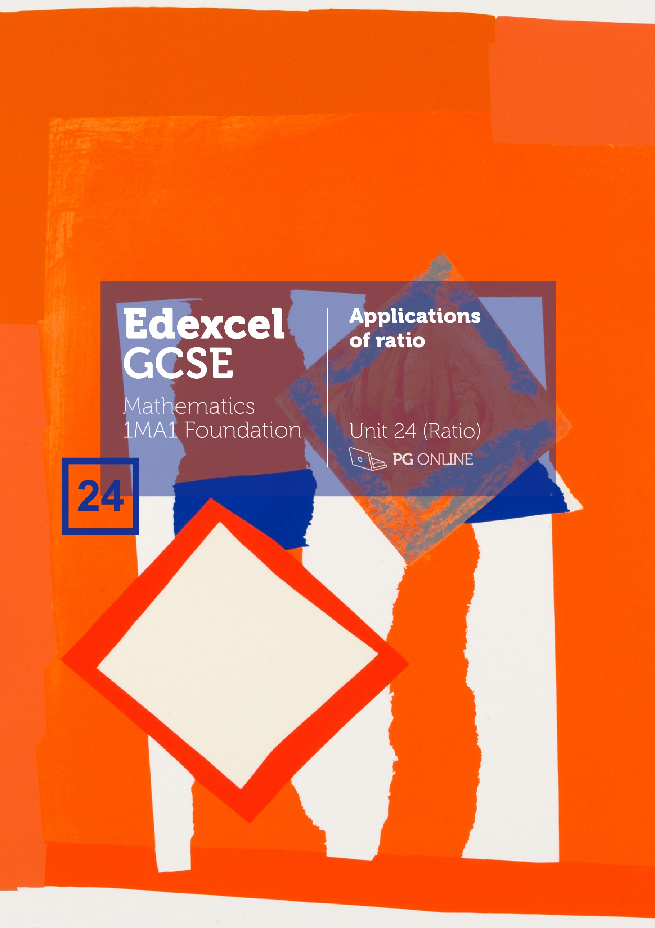

Copyright

© 2019 PG Online Limited

The contents of this unit are protected by copyright.

This unit and all the worksheets, PowerPoint presentations, teaching guides and other associated files distributed with it are supplied to you by PG Online Limited under licence and may be used and copied by you only in accordance with the terms of the licence agreement between you and PG Online Limited. Except as expressly permitted by the licence, no part of the materials distributed with this unit may be used, reproduced, stored in a retrieval system, or transmitted, in any form or by any means, electronic or otherwise, without the prior written permission of PG Online Limited.

Licence agreement

This is a legal agreement between you, the teaching institution, and PG Online Limited. PG Online Limited grants to you a non-exclusive, non-transferable, revocable licence to use this unit and all the worksheets, PowerPoint presentations, teaching guides and other associated files distributed with it in the course of teaching by your teachers and/or employees.

The materials distributed with this unit may be copied and used by your teachers and/or employees on a single site only in the course of their teaching. You warrant that you shall not, and shall procure that each of your teachers and/or employees shall not, share in any way any of the materials or part of the materials with any third party, including users on another site or individuals who are teachers and/or employees of a separate institution. You acknowledge and agree that the materials must remain with you, the teaching institution, and no part of the materials may be transferred to another institution. You also warrant that you shall not, and shall procure that each of your teachers and/or employees shall not, procure, authorise, encourage, facilitate or enable any third party to reproduce these materials in whole or in part without the prior permission of PG Online Limited.

In consideration of the licence granted to you, you shall indemnify PG Online Limited against all liabilities, costs, expenses, damages and losses (including but not limited to any direct, indirect or consequential losses, loss of profit, loss of reputation and all interest, penalties and legal costs and all other professional costs and expenses) suffered or incurred by PG Online Limited arising out of or in connection with the exercise by you of your rights granted under this licence.

Teacher’s Guide

Introduction

This teacher’s guide contains a detailed lesson plan to accompany the set of PowerPoint slides and worksheets for each lesson.

The lessons are designed to form a basis for ideas for the teacher and should be adapted to suit the teaching style and preferences of the individual teacher, and the resources and nature of the individual school or Mathematics department.

The material supplied for this unit includes:

* 7 PowerPoint presentations, each designed to cover one lesson
* 7 worksheets / homework sheets
* An end-of-unit test for assessment purposes

Summary

The unit is subdivided into seven lessons (plus a test) and is intended to be taught over approximately two or three weeks. The unit covers aspects of Assessment Points R1, R4, R9, R11, R12, R13, R14, R16, A14 and N12 of the Edexcel GCSE Mathematics specification. It is in the linear nature of the specification that this material will be revisited and applied, and more complex and varied problems introduced, in many subsequent units.

Learning Outcomes for the unit

**At the end of this Unit all students should be able to:**

* Recognise recurring and terminating decimals
* Convert fractions such as $\frac{3}{7}$ and $\frac{2}{3}$ into recurring decimals using a calculator
* Understand and use density and pressure in simple contexts
* Write lengths, areas and volumes of two shapes as ratios
* Draw and interpret simple speed–time graphs
* Interpret graphs of containers filling and emptying
* Understand direct proportion
* Use compound interest

**At the end of this unit, students aiming to achieve a Grade 4 or 5 should be able to:**

* Convert fractions such as $\frac{3}{7}$ and $\frac{2}{3}$ into recurring decimals without the use of a calculator
* Understand and use density and pressure in more complex situations
* Convert between metric units of area, and volume and capacity
* Interpret the gradient of a speed-time graph as a rate of change
* Interpret equations that describe direct and inverse proportion
* Understand direct and inverse proportion, and interpret equations
* Set up, solve and interpret solutions to compound interest problems
* Make calculations involving repeated percentage change
* Set up, solve and interpret the answers in growth and decay problems

Previous Learning

Students should have studied basic Mathematics up to the end of KS3.

Suggested Resources

A close up of text on a white background

Description generated with high confidence

This Edexcel GCSE Foundation Student book provides a fresh new approach to traditional textbooks. It is comprehensive in its coverage of the full Edexcel GCSE Maths Foundation specification, but this student book is a resource which can be used either to complement the teaching and learning materials produced by PG Online for this specification or as a stand-alone student book. It comprises 25 sections, each focusing on aspects from one of the strands of the specification. Each section is further divided into six or seven chapters; one chapter representing the learning from approximately one lesson.

Each chapter provides concise explanations supported by worked examples, concluding   
with a set of graduated questions to apply the learning. To support the Mastery approach, appropriate use of procedural variation and representations is made, with examination-style questions.

Vocabulary

Vocabulary associated with this Unit, such as:

Terminating decimals, recurring decimals, percentage increase, percentage decrease, multiplier, density, volume, mass, pressure, force, area, ratio, simplest form, capacity, length, volume, speed-time graph, gradient, rate of change, acceleration, speed, distance, time, direct proportion, inverse proportion, directly proportional, inversely proportional, simple interest, compound interest, appreciation, depreciation, decay, growth

Graded challenge level

To provide appropriate stretch and challenge for students who are aiming for Grades 4 and 5, selected questions and activities are marked as ‘more challenging’ denoted with a silver medal and image of a runner, or ‘most challenging’ denoted with a gold medal and an image of a sprinter.

|  |  |  |  |  |
| --- | --- | --- | --- | --- |
|  | More challenging |  |  | Most challenging |

Assessment

An exercise sheet and an answer sheet are provided for each lesson. This may be wholly or partially completed in the lesson or given as homework. Students will sit an assessment using exam-style questions relevant to the objectives in the unit at the end of the lesson sequence. The assessment will take about one hour to complete.

Lesson plan

|  |
| --- |
| Lesson 1 Terminating and recurring decimals |
| Learning objectives   * Convert between fractions, decimals and percentages * Recognise terminating decimals and recurring decimals * Convert fractions such as $\frac{3}{7}$ and $\frac{2}{3}$ into recurring decimals with and without the use of a calculator |
| Resources   * PowerPoint Guide: L1 Terminating and recurring decimals * L1 Exercise sheet 1 * L1 Exercise sheet 1 Answers |
| Prior learning  Student should already:   * Be able to convert between fractions, decimals and percentages * Interpret fractions and percentages as operators |
| Prerequisite PG units   * Unit 4 * Unit 6 * Unit 8 |
| Common misconceptions   * When working with fractions, some students do not appreciate that a fraction can be both a number and an operator * When converting a fraction to a decimal without a calculator, some students confuse the method of division * When working with terminating decimals, some students think that these will only have one or two decimals places in them |
| Content and Resources |
| Starter  The starter provides a recap on converting between fractions, decimals and percentages. Encourage students to explain clearly how to do this – and if appropriate to write methods down, along with giving examples of how their methods work.  The second slide gives a table for students to complete in order to put their methods into use. Allow the use of a calculator at this stage to avoid problems when finding the equivalents for $\frac{7}{11}$ (a non-calculator method for this will be dealt with fully later on in the lesson).  Main  Decimals  The decimals from the starter are presented and students asked to sort them into two groups. This can be done in a variety of ways - those with even digits, those greater than or less than a value and so on. Encourage students to find different ways to do this.  The slides then move on to show the decimals sorted into terminating and non-terminating decimals. Ensure that students understand the difference.  Terminating decimals  The focus now turns to the terminating decimals; ensure that students realise that some terminating decimals may have quite a few decimal places in them. Support students to use their calculator to input a fraction and to convert it to a decimal. They should be confident to use a calculator to work with fractions when permitted. The terminating decimals in the list are $\frac{1}{4}, \frac{3}{10}$ and $\frac{7}{8}$ (0.25, 0.3 and 0.875). A terminating decimal is produced when the denominator is a factor of a power of 10.  Non-terminating decimals  The lesson now moves onto consider non-terminating decimals and subsequently their link with recurring decimals. When exploring non-terminating decimals with a calculator, students will discover the use of the dot notation to show recurring digits. Allow students to explore converting different fractions in order to work out for themselves how the dot notation works.  On the final slide of this section non-terminating decimals are linked to recurring decimals. In fact, all rational non-terminating decimals are recurring. This knowledge is not required for this level and so is not fully explained; however, some students may recall that Pi is a non-terminating but also non-recurring decimal number (however not rational).  Recurring decimals  The lesson now moves on to consider recurring decimals and the use of the dot notation considered. A practice slide gives students an opportunity to consolidate their learning so far in the lesson.  Fractions to decimals  The final series of slides for the lesson consider how to convert a fraction to a decimal without the use of a calculator. Some students may find this tricky and this learning may be appropriate only for those students aiming for Grade 4 or 5. The slides demonstrate how to perform the division calculation producing a terminating decimal. The final slide of the section asks student to convert $\frac{2}{3}$ which will of course produce a recurring decimal. Students may need guidance on how/when to stop when performing this division.  Alex’s numbers in ascending order are: $\frac{13}{20}$, 66.6%, $\frac{2}{3}$, 0.67  Thirteenths  A final reasoning activity focuses on the family of thirteenths and the patterns which can be found in the digits of the recurring decimals. Allow students time to explore these and discover and describe the patterns themselves.  Plenary  A plenary activity is provided to check understanding of recurring and terminating decimals. Confusion over 0.3 and $\frac{1}{3}$ is very common and so ensure students are clear about their difference and can explain why they are not the same.  Exercise Sheet  Use Exercise Sheet 1 for extra exercises or set as homework if appropriate. All the exercise sheets are a mixture of straightforward calculation, reasoning and problem solving. Some questions are designed to provoke discussion and discovery. They are not all exam-type questions. |

Acknowledgements

The authors and publisher would like to thank all contributors for their kind permission to reproduce their photographs or images, screenshots of their websites or other copyright material in the PowerPoint Guides.

Images otherwise stated © Shutterstock

Electric car image: Michael Shake / Shutterstock.com

Every effort has been made to trace the copyright holders and we apologise in advance for any unintentional omissions. We would be pleased to insert the appropriate acknowledgement in any subsequent edition of this publication.

This material contains links to relevant websites featured in the teacher’s guide. Every effort has been made to ensure that at the time of distribution, the links remain unbroken, the material remains up-to-date and that links are not inadvertently linked to sites that could be considered offensive. PG Online cannot be held responsible for the content of any website mentioned in this material. It is sometimes possible to find relocated sites by typing the original URL into a browser. Any errors should be reported directly to support@pgonline.co.uk and changes will be made in any subsequent editions of the material.

Artwork

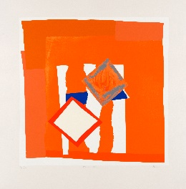

Orange Field © Sandra Blow Estate 2000

Silk Screen Print (28.5” × 28.5”)

www.sandrablow.com